INPUT/OUTPUT AND ERROR HANDLING

EC 5080

SOFTWARE CONSTRUCTION

WIJAYAWARDHANA W.A.H.A.

2019/E/166

SEMESTER 05

16 SEPTEMBER 2022

QUESTION 02

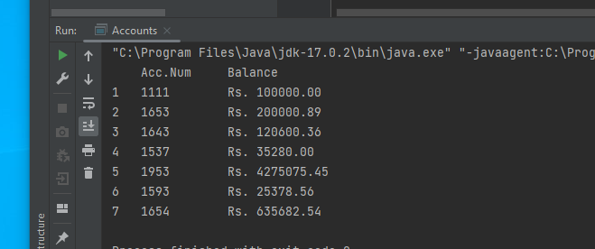

FIGURE 01 – OUTPUT

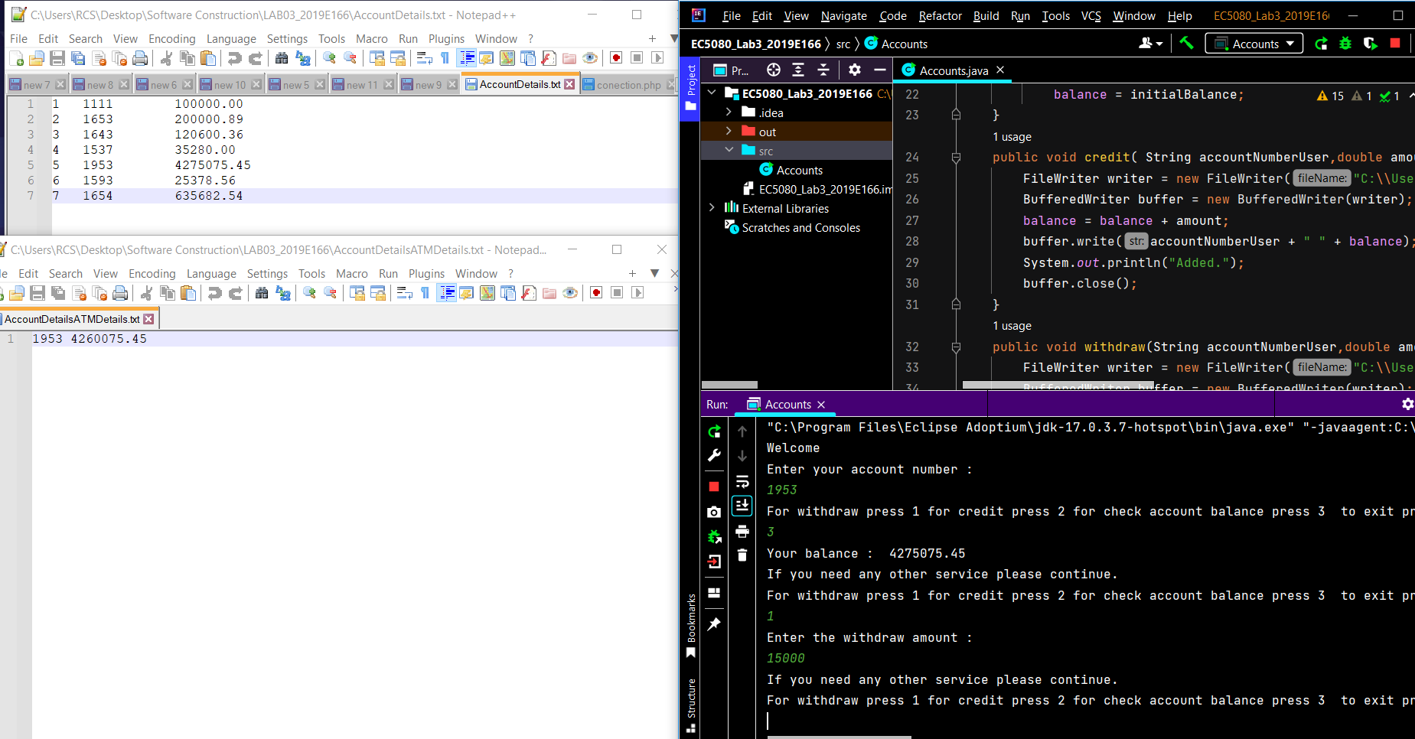

FIGURE 02 – GETTING CUSTOMER DETAILS

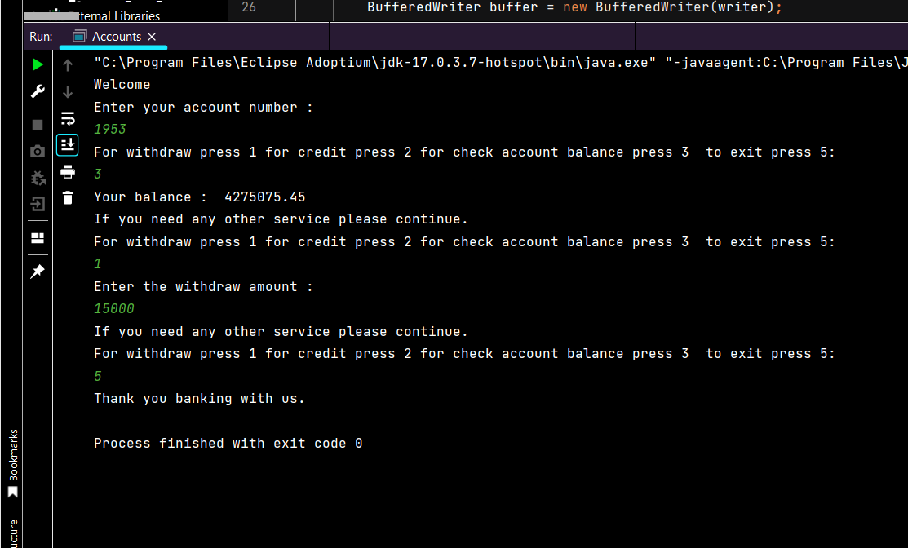

FIGURE 03

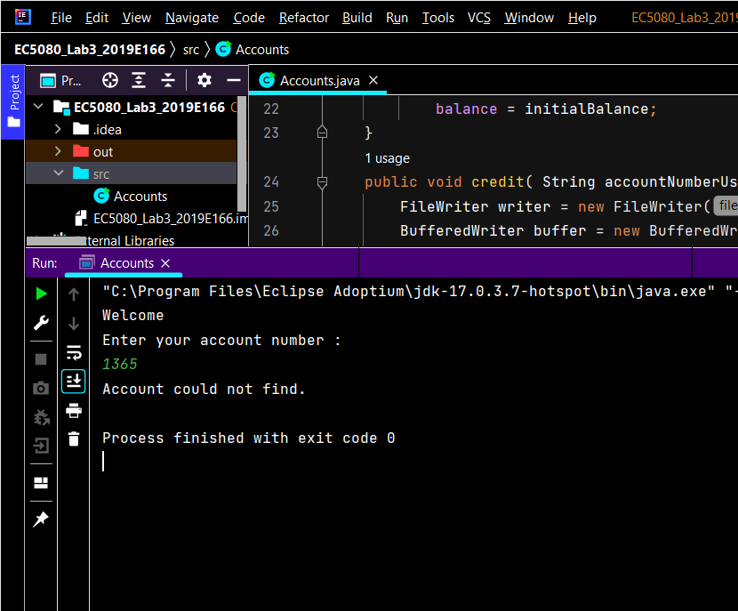

FIGURE 04